# Hero Competitions

## Database Usage

Write queries to match the output in the screenshots

1. Examine the create.sql file and create an [ERD](https://www.visual-paradigm.com/guide/data-modeling/what-is-entity-relationship-diagram/) of what you see.
2. Counting Rows

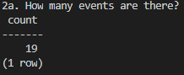

Your Query: SELECT COUNT(id) FROM w5_EVENT;

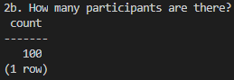

Your Query: SELECT COUNT(id) FROM w5_PARTICIPANT;

1. Event Details

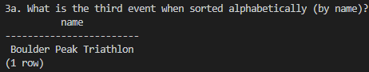

Your Query: SELECT name FROM w5_EVENT ORDER BY name LIMIT (1) OFFSET (2);

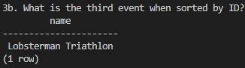

Your Query: SELECT id, name FROM w5_EVENT ORDER BY id LIMIT (1) OFFSET (2);

1. Event Participants

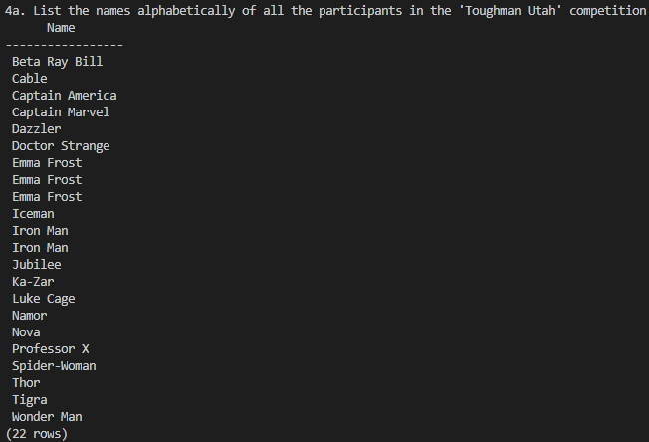

Your Query: SELECT ep.participant_id, p.id, p.name

FROM w5_EVENT_PARTICIPANT ep

JOIN w5_PARTICIPANT p ON p.id = ep.participant_id

WHERE ep.event_id = 5

ORDER BY p.name;

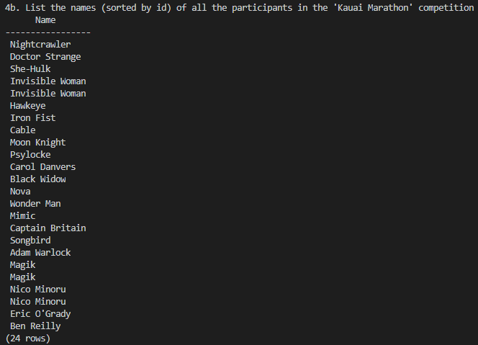

Your Query: SELECT ep.participant_id, p.id, p.name

FROM w5_EVENT_PARTICIPANT ep

JOIN w5_PARTICIPANT p ON p.id = ep.participant_id

WHERE ep.event_id = 11

ORDER BY p.id;

1. Participant Details
   1. How many competitions has Black Panther competed in?

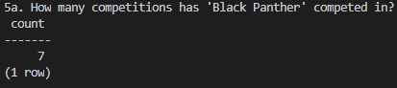

Your Query: SELECT COUNT(event_id) FROM w5_EVENT_PARTICIPANT WHERE participant_id = 32;

* 1. How can you verify that your count is correct?

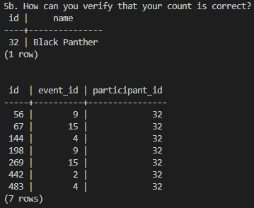

Your Queries: SELECT id, name FROM w5_PARTICIPANT WHERE name = 'Black Panther';

SELECT id, event_id, participant_id FROM w5_EVENT_PARTICIPANT WHERE participant_id = 32;

* 1. Who has competed in the most competitions? How many have they competed in?

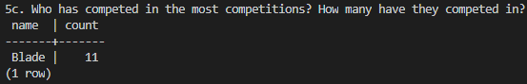

Your Query: SELECT p.name, COUNT(ep.participant_id)

FROM w5_EVENT_PARTICIPANT ep

JOIN w5_PARTICIPANT p ON p.id = ep.participant_id

GROUP BY p.name

HAVING COUNT (ep.participant_id)=(

SELECT MAX(mycount)

FROM (SELECT ep.participant_id, COUNT(ep.participant_id) mycount

FROM w5_EVENT_PARTICIPANT ep

GROUP BY ep.participant_id) AS max);

* 1. Who has competed in the least competitions? How many have they competed in?

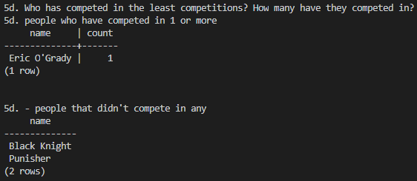

Your Query: SELECT p.name, COUNT(ep.participant_id)

FROM w5_EVENT_PARTICIPANT ep

JOIN w5_PARTICIPANT p ON p.id = ep.participant_id

GROUP BY p.name

HAVING COUNT (ep.participant_id)=(

SELECT MIN(mycount)

FROM (SELECT ep.participant_id, COUNT(ep.participant_id) mycount

FROM w5_EVENT_PARTICIPANT ep

GROUP BY ep.participant_id) AS min);

echo '5d. people who have competed in 1 or more'

SELECT p.name, COUNT(ep.event_id) AS 'number of competitions'

FROM w5_EVENT_PARTICIPANT ep

JOIN w5_PARTICIPANT p ON p.id = ep.participant_id

GROUP BY p.name;

echo '5d. - people that didn''t compete in any'

SELECT name

FROM w5_PARTICIPANT

WHERE id NOT IN (SELECT participant_id FROM w5_EVENT_PARTICIPANT);

1. EXTRA QUERIES
   1. Is there anyone who has competed in the same competition twice?
      1. SELECT p.name, event_id, COUNT(event_id)
      2. FROM w5_EVENT_PARTICIPANT ep
      3. JOIN w5_PARTICIPANT p ON p.id = ep.participant_id
      4. GROUP BY p.name, event_id
      5. HAVING COUNT(event_id)>1;
   2. Which event had the most competitors?
      1. SELECT e.name, COUNT(ep.event_id)
      2. FROM w5_EVENT_PARTICIPANT ep
      3. JOIN w5_EVENT e ON e.id = ep.event_id
      4. GROUP BY e.name
      5. HAVING COUNT (ep.event_id)=(
      6. SELECT MAX(mycount)
      7. FROM (SELECT ep.event_id, COUNT(ep.event_id) mycount
      8. FROM w5_EVENT_PARTICIPANT ep
      9. GROUP BY ep.event_id) AS max);
   3. Which event had the least competitors?
      1. SELECT e.name, COUNT(ep.event_id)
      2. FROM w5_EVENT_PARTICIPANT ep
      3. JOIN w5_EVENT e ON e.id = ep.event_id
      4. GROUP BY e.name
      5. HAVING COUNT (ep.event_id)=(
      6. SELECT MIN(mycount)
      7. FROM (SELECT ep.event_id, COUNT(ep.event_id) mycount
      8. FROM w5_EVENT_PARTICIPANT ep
      9. GROUP BY ep.event_id) AS min);
   4. List all competitors that competed in the same event at least once
      1. SELECT p.name, event_id, COUNT(event_id)
      2. FROM w5_EVENT_PARTICIPANT ep
      3. JOIN w5_PARTICIPANT p ON p.id = ep.participant_id
      4. GROUP BY p.name, event_id
      5. HAVING COUNT(event_id)>1;
   5. How many people competed in swim competitions?
      1. SELECT COUNT(ep.participant_id)
      2. FROM w5_EVENT_TYPE et
      3. JOIN w5_EVENT e ON et.id = e.type
      4. JOIN w5_EVENT_PARTICIPANT ep ON ep.event_id = e.id
      5. WHERE et.name = 'Swim Competition';
   6. What type of competition has the most overall competitors?
      1. SELECT et.name, COUNT(ep.participant_id)
      2. FROM w5_EVENT_TYPE et
      3. JOIN w5_EVENT e ON et.id = e.type
      4. JOIN w5_EVENT_PARTICIPANT ep ON ep.event_id = e.id
      5. WHERE et.name = 'Swim Competition'
      6. GROUP BY et.name;

## PHP

1. Create a php page that will show all the names and rendered images of the events.

<http://aqueous-wave-14996.herokuapp.com/assignments/week5/class/>